Artificial Neural Networks (ANN) – Detailed Notes

🔹 1. What is an Artificial Neural Network?
An Artificial Neural Network (ANN) is a machine learning model inspired by how neurons work in the human brain.
🧠 Human Brain:
- Neurons process information via electrical signals.
- They connect through synapses and "fire" when activated.
🖥️ ANN:
- Artificial neurons are mathematical functions.
- They connect via weights and process inputs to generate outputs.

🔹 2. ANN Architecture
📌 Layers:
Layer | Role
Input Layer | Accepts features of the dataset (e.g., pixels of an image).
Hidden Layer(s) | Performs complex computations and feature extraction. Can be multiple.
Output Layer | Provides the final result (e.g., classification like cat/dog).

📌 Each Neuron:
- Receives multiple inputs.
- Applies weights to inputs.
- Adds a bias.
- Passes result through an activation function.

🔹 3. Neuron Mathematical Formula
A single artificial neuron does the following:
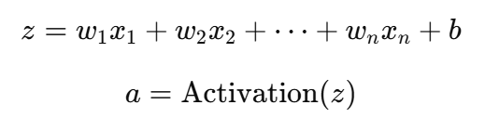
Where:

🔹 4. Activation Functions
These introduce non-linearity, allowing the network to learn complex patterns.
Function | Formula | Use Case
Sigmoid | 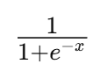 | Binary classification
Tanh | 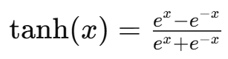 | Output in [-1, 1]
ReLU | 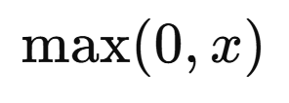 | Fast learning; common in deep networks
Leaky ReLU | 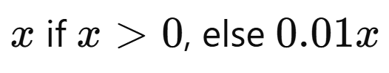 | Solves "dead neuron" problem in ReLU
Softmax | Converts outputs into probabilities | Used in output layer of multi-class classification

🔹 5. Forward Propagation
Step-by-step data flow:
- Input is multiplied with weights and bias added.
- Output passed through activation function.
- Output of one layer = input to next.
- Final output generated.

🔹 6. Loss Function
Measures how far the network’s prediction is from the actual value.
Common Loss Functions:
- Mean Squared Error (MSE):
1n∑(y−y^)2\frac{1}{n} \sum (y - \hat{y})^2n1​∑(y−y^​)2
- Cross-Entropy Loss (for classification)

🔹 7. Backpropagation + Gradient Descent
Backpropagation = How the network learns.
Steps:
- Calculate loss/error at output.
- Compute gradients (how much each weight contributed to error).
- Update weights using Gradient Descent:
w:=w−α⋅∂Loss∂ww := w - \alpha \cdot \frac{\partial \text{Loss}}{\partial w}w:=w−α⋅∂w∂Loss​
Where α\alphaα is the learning rate.
- Repeat over multiple epochs (full passes over training data).

🔹 8. Hyperparameters to Tune
Hyperparameter | Description
Learning Rate | Size of each step during weight updates
Epochs | Number of times the entire dataset is passed through
Batch Size | Number of samples processed before updating the model
Hidden Layers | Number/depth of hidden layers
Neurons per layer | Affects model complexity and performance

🔹 9. Example Use Case: Handwritten Digit Recognition (MNIST)
- Input: 28x28 grayscale image → 784 inputs
- Hidden Layers: Use ReLU
- Output: 10 neurons → Each neuron corresponds to digit 0–9
- Output Activation: Softmax
- Loss Function: Cross-Entropy

🔹 10. Types of Neural Networks (Extensions of ANN)
Type | Description
Feedforward Neural Network (FNN) | Basic ANN; data moves forward only
Convolutional Neural Network (CNN) | For images
Recurrent Neural Network (RNN) | For sequences (like time series or text)
Deep Neural Network (DNN) | ANN with many hidden layers (deep learning)

🔹 11. Real-Life Applications
- ✅ Face Recognition
- ✅ Speech-to-Text (Google Assistant, Siri)
- ✅ Self-driving Cars (Image + Sensor analysis)
- ✅ Medical Diagnosis (X-ray, ECG classification)
- ✅ Stock Market Prediction

